**Title:** Write a program which contains a class named Student and the member of the class are a construct without parameter, a constructor with para meter, 3 data member named name,id, and cgpa, 2 member function named get_cgpa,show_info.Return type of get_cgpa is double.Now print all the info of student.

**Source Code:**

#include <iostream>

using namespace std;

class student {

double cgpa;

public:

string name;

long long id;

double get_cgpa();

void show_info();

student();

student(double, string, long long );

~student(); };

inline double student::get_cgpa() {

cout << "Enter CGPA: ";

cin >> cgpa;

return cgpa; }

void student::show_info() {

cout << "Name of s:"<< name << endl;

cout << "ID of s:"<< id << endl;

cout << "CGPA of s:"<< cgpa<< endl; }

student::student() {

name='\0';

cgpa = 0.00;

id = 0; }

student::student(double x, string y, long long z) {

cgpa = x;

name = y;

id = z; }

student::~student() {

cout << "This is destructor" << endl; }

int main() {

student s1, s2(4.00, "nowshin", 17183103020);

cout << "CGPA of s1: "<< s1.get_cgpa() << endl;

cout << "CGPA of s2: "<< s2.get_cgpa() << endl;

s1.show_info();

s2.show_info();

return 0;

}

**Output:**

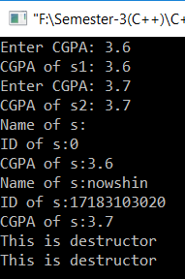



[Date]

Assignment On

Use of inline function

**Course Title:** Object Oriented Programming Language

**Course Code:** CSE 121

**Submitted By:**

Name: Syeda Nowshin Ibnat

ID :17183103020

Intake :39

Section: 1

Program:B.SC. in CSE

**Submitted To:**

Name: M.M. Fazle Rabbi

Assistant Professor, Dept. of CSE

at Bangladesh University of Business and Technology.

**Date of Submission:20.02.19**